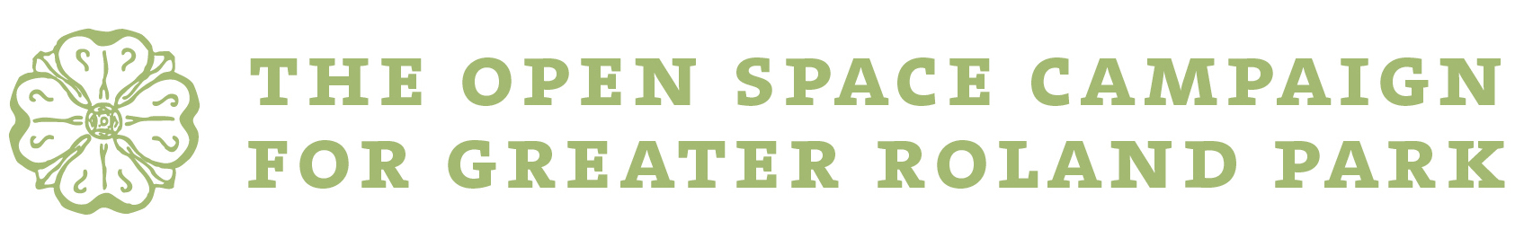

Pledge Agreement

In support of the Open Space Campaign and to assist in the preservation and improvement of the environment of Greater Roland Park:

I/we hereby pledge $ ______________________________________ to The Roland Park Community Foundation, Inc. to be dedicated for the use of the Open Space Campaign for Greater Roland Park.

I/we have enclosed $ _______________________________________.

I/we prefer to make pledge payments of $ __________________________________________:
_____ Annually over the next ________ years.
_____ On the following schedule: _____________________________________________________

I/we have included The Foundation in my/our will(s). _____ Yes _____ No

I/we would like information about including the Foundation in my/our will(s). _____ Yes _____ No

My/our gift is
_____ Designated for general campaign purposes
_____ Designated to a specific campaign project: ___________________________________________

My/our gift is
_____ In honor of: ______________________________________________________
_____ or in memory of: _________________________________________________
_____ Anonymous

Name: ____________________________ Name: __________________________________
(please print) (please print)

Signature: __________________________ Signature: ____________________________________

Date: _____________________________ Date: __________________________________

Address: _____________________________________________________________________________________

City: ____________________________________________ State: __________ Zip: _____________

Please make checks payable to The Roland Park Community Foundation, Inc. Contact The Foundation office if stock gifting instructions are needed (410-464-2525). Pledges of $1,000 or more may be paid over a number of years up to five. The Foundation will send reminders unless otherwise requested.

The Roland Park Community Foundation, Inc. 5115b Roland Avenue, Baltimore, MD 21210
A section 501(c)(3) organization

