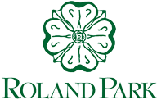

Civic League Monthly Board Meeting
In person and via Zoom
Wednesday-June 1, 2022

Routine Business
  - In our Community!
  - Speaker Series update
  - Welcome new Board members; assignment to committees
  - Approval of 2022-23 budgets
  - September Socials

- Old Business
  - Update re: new database accounting system
  - July 4th parade
  - June 22 State’s Attorney candidates forum

- Committee Reports
- Adhoc Committee on 5G
- Master Plan Committee
- Landscape Committee

- Adjourn
“The Roland Park Civic League is a civic governing body that addresses matters affecting the interests of residents. Its purpose is to foster the common good and welfare of its members, to take action on those matters of mutual interest, and to otherwise represent the people of Roland Park.”

